**Lab Report 2 Part 2**

Title: Finding Dory

Notice: Dr. Bryan Runck

Author: Maisong Francis

Date: 3/3/2021

**Project Repository:** *https://github.com/msongfrancis/GIS5572.git*

**Abstract**

In order to solve Dory’s optimal path problem to her fly-fishing spot, there are multiple factors to consider based on her preferences such as where farms and waterbodies are, and how steep her path is. The datasets to be used are the NLCD 2016, streams for barriers, roads to discern crossable streams, and a DEM to calculate the slope. Using various methods such as reclassifying, rescaling, calculating cost rasters, and the optimal path tool, Dory’s path was revealed. Her path appears to be in low-cost cells and outputs a path of almost 9 miles. However, there are some issues with her path such as it diagonally crossing between two stream cells. This appears to be correct however in real life, the stream is continuous. Overall, this was an effective method to help Dory, but using a finer resolution dataset and including bridges would output a more accurate optimal path.

**Problem Statement**

Dory needs a path from her farm to the North Picnic area in the Whitewater State Park. She has preferences such as preferring not to walk through farm fields, crossing water bodies, and gradual slope.

*Table 1. Data required to solve Dory’s fly-fishing problem.*

|  |  |  |  |  |  |  |
| --- | --- | --- | --- | --- | --- | --- |
| **#** | **Requirement** | **Defined As** | **Spatial Data** | **Attribute Data** | **Dataset** | **Preparation** |
| 1 | Farm locations | Crop lands | Raster |  | [Mn Geospatial Commons](https://gisdata.mn.gov/dataset/trans-roads-mndot-tis) |  |
| 2 | Water body crossing | Areas where dory can cross the water body like streets | Vector and raster | Whether it’s water or not. |  |  |
| 3 | Slope | Gradual slope of the landscape. | Raster | Slope percentage |  | Calculated from DEM in ArcGIS pro |
| 4 | Where is Dory going to | Dory’s destination | Point | Coordinates |  |  |

**Input Data**

The landcover dataset will be used to identify crops, wetlands, and streams. The lc dataset comes from the NLCD 2016 and includes classification for 10 sets. The DEM data comes from USGS with a resolution 30 meters and will be used to calculate slope. The streams dataset comes from the MNDNR and will be used to also identify uncrossable barriers. The roads dataset was collected in 2012.

*Table 2. Input data for Dory’s problem*

|  |  |  |  |
| --- | --- | --- | --- |
| **#** | **Title** | **Purpose in Analysis** | **Link to Source** |
| 1 | Landcover | Identify crops, wetlands, and streams | [Mn Geospatial Commons](https://gisdata.mn.gov/dataset/biota-landcover-nlcd-mn-2016) |
| 2 | Streams | Barriers in the analysis | [MN Geospatial Commons](https://gisdata.mn.gov/dataset/water-strahler-stream-order) |
| 3 | DEM | Calculate slope for gradual slope | [MN Geospatial Commons](https://gisdata.mn.gov/dataset/elev-30m-digital-elevation-model) |
| 4 | Roads | Identify where you can go over streams | [MN Geospatial Commons](https://gisdata.mn.gov/dataset/trans-roads-mndot-tis) |

**Methods**

Dory had many preferences. To ensure she did not walk through any farm fields or muddy terrain, cross any water bodies, and take the most gradual path in terms of slope, the data incorporated were streams, landcover, roads, and DEM. After I retrieved the datasets from Google Places API and MN Geospatial commons, I made a point dataset with her start and destination coordinates. From there, I buffered the start and end points by 8 km and clipped all the datasets to that extent to make it easier to work with. I reclassified the landcover data from 1-10 where 10 was high cost to be in that cell. These correlated with crops and wetlands. For Streams and roads, I buffered them both and erased the roads from the streams to find uncrossable streams. The DEM was used to calculate slope. I rescaled the DEM and the cost accumulation for the streams from 1-10 using MSSMALL (because small values were higher cost). Then I created a weighted sum with the reclassified landcover, the streams, and the slope to get a cost raster. From there, I created a cost raster from the source and the weighted sum and calculated the cost raster and the back direction raster. Then I used the optimal pat as line tool to figure out Dory’s shortest path based on the cost raster with everything considered. (Fig 1).

*Figure 1. Data flow diagram.*

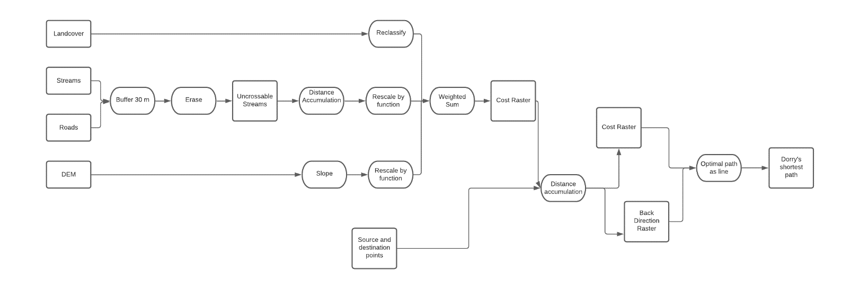

**Results**

The optimal path analysis outputs a path that measures almost 9 miles in length. The line does not run through high-cost areas such as crops, wetlands, and streams based on the cost analysis (Fig 2). Areas that are red coincide with crops and waterbodies. Areas that are orange are medium cost cells and green cells are the lowest cost cells.

Figure 2. Cost analysis to find Dory’s optimal path to her fly-fishing spot.

**Results Verification**

I was able to verify my results by turning off and on the different overlays. Where the optimal path was, there wasn’t a stream, crop, or high percentage slope change. I think another way to assess my result could be to run the analysis again on a finer resolution dataset to see if it matched.

**Discussion and Conclusion**

*What did you learn? How does it relate to the main problem?*

My results to find the optimal path for Dory yielded an almost 9-mile path. The path when compared to the datasets were accurate except the optimal path would sometimes run between two diagonal pixels with high cost. In real life, this means Dory would have to cross the stream. Something that would make this better is a bridge dataset. Areas of stream where it was crossable would be easily identifiable.

Something else I learned was using the rescale function. To perform a cost analysis, each dataset had to be rescaled for a 1-10 scale to make sure all datasets were equal. I did not weigh the datasets differently, but I think stream barriers would have been weighed more because they were high cost to cross than something like a muddy crop field. Overall Dory can get to the destination point in white water; however, it would take her 9 miles of walking and she may have to cross streams. In the cost raster the low to medium cost cells appears to align with roads. Overall cost analysis helped to identify where Dory can travel, but I think because this was a more detailed terrain, perhaps using a resolution finer than 30 meters would be better.

**References**

**Self-score**

*Fill out this rubric for yourself and include it in your lab report. The same rubric will be used to generate a grade in proportion to the points assigned in the syllabus to the assignment.*

|  |  |  |  |
| --- | --- | --- | --- |
| **Category** | **Description** | **Points Possible** | **Score** |
| **Structural Elements** | All elements of a lab report are included **(2 points each)**:  Title, Notice: Dr. Bryan Runck, Author, Project Repository, Date, Abstract, Problem Statement, Input Data w/ tables, Methods w/ Data, Flow Diagrams, Results, Results Verification, Discussion and Conclusion, References in common format, Self-score | 28 | **23** |
| **Clarity of Content** | Each element above is executed at a professional level so that someone can understand the goal, data, methods, results, and their validity and implications in a 5 minute reading at a cursory-level, and in a 30 minute meeting at a deep level **(12 points)**. There is a clear connection from data to results to discussion and conclusion **(12 points)**. | 24 | **20** |
| **Reproducibility** | Results are completely reproducible by someone with basic GIS training. There is no ambiguity in data flow or rationale for data operations. Every step is documented and justified. | 28 | **28** |
| **Verification** | Results are correct in that they have been verified in comparison to some standard. The standard is clearly stated **(10 points)**, the method of comparison is clearly stated **(5 points)**, and the result of verification is clearly stated **(5 points)**. | 20 | **20** |
|  |  | 100 | **91** |